**The Little Free Pantry**

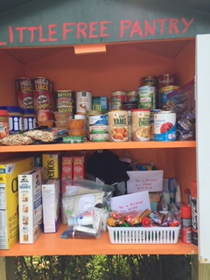

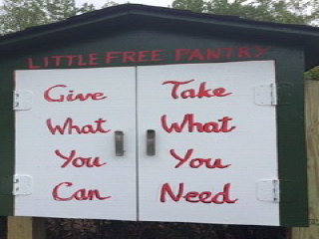

**FREE NO SIGN-UP ANONYMOUS OPEN 24/7**

The Little Free Pantry is located at St Matthew’s UMC’s parking lot and is additional Bowie community resource that provides emergency food and personal hygiene items. The Little Free Pantry is for neighbors helping neighbors.

How you can get involved?

* Give what you can. Please provide nonperishable, unexpired food and hygiene products that are in unopened, unbreakable containers.  If the LFP is full, please bring back the items another time. Thanks!
* Take what you may need. Please take any items you need.
* Spread the word about the Little Free Pantry
* Ask questions or report concerns to [lfp@stmatthews-bowie.org](mailto:lfp@stmatthews-bowie.org)

**Location**: Left side of Parking Lot Entrance Near Visitor Parking



**St Matthew’s United Methodist Church**

**14900 Annapolis Road**

**Bowie, Maryland 20715**

[**lfp@stmatthews-bowie.org**](mailto:lfp@stmatthews-bowie.org)

**https://stmatthews-bowie.org/missions/local-mission-opportunities/the-little-free-pantry**