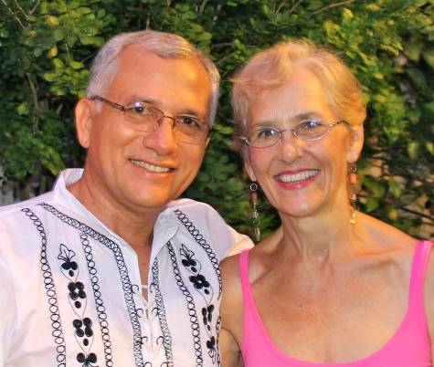
"Lent is not really about sacrifice and deprivation, it is about freedom and transformation. It is a time to acknowledge the deep longing of our hearts for a more intimate walk with God and consider ways that we might accomplish that..."
Covenant Letter from Nan and Miguel, March 2014
Thank you for generously supporting Missionaries: Miguel Mairena # 12877Z and Nan McCurdy #10801Z
The following reflection is by Christine Sine and it is from "Missio Alliance", March 5, 2014.
Most of us think of Lent as a time to give up a non-essential food item like chocolate or we consider cutting back on activities like social media and TV. Some of us fast for a day or two and get a warm glow of satisfaction because of our sacrifices. Unfortunately these observances make little if any difference to the ongoing journey of our lives.
Lent is not really about sacrifice and deprivation, it is about freedom and transformation. This is not a time to wallow in our sins and shout, “Woe is me!” But it is certainly a time to acknowledge our brokenness, repent of our sins and journey towards wholeness. It is a time to acknowledge the deep longing of our hearts for a more intimate walk with God and consider ways that we might accomplish that....
A couple of months ago I came across this quote from Thomas Merton’s Seasons of Celebration:
"God’s people first came into existence when the children of Israel were delivered from slavery in Egypt and called out into the desert to be educated into freedom, to learn to live with no other master but God himself. "
For me Merton’s (Thomas Merton, Trappist Monk of the Abbey of Gethsemani, KY, who had a major influence on Nicaraugan Trappist Monk, Ernesto Cardenal) words sum up the true purpose of Lent. God wants to educate us into the true freedom of following God with all our hearts and minds and actions. In this season God wants to liberate us from the bondages of our slavery to self centredness, greed, busyness, and rampant consumerism. God wants us to help others be liberated from the bondages of poverty, sex trafficking, imprisonment, addictions, injustice and disease. And God wants us to commit to the liberation of our earth from pollution, deforestation and species extinction.
The ashes used in church services on Ash Wednesday are traditionally made by burning the Palm Sunday crosses from the previous year. Last year I did just that and it was so impacting that I have started a new tradition that I intend to perform each year. I burnt my cross, reminding myself that the repentance I seek at this season is only possible because of the incomprehensible gift of Christ and his death on a cross 2,000 years ago. Burning my cross reminds me that the crucifixion is not really about fasting and mourning but rather about transformation. We look beyond the cross to the joy of entering the life of God’s kingdom and this is indeed a season to prepare us for that new life in Christ.
As you ... journey through Lent think about the parts of your life that still need to be transformed. What is one place of brokenness you long to see transformed? What practices could you adopt during Lent to see that transformation occur and experience the freedom of following God in new ways?
Dear Friends,
In our work with women in the remote municipality of San Juan de Limay, near the Honduran border we were able to facilitate various training processes with two groups of women so they could better know and defend their rights.
As you know, Miguel is a lawyer and he designed various popular education trainings for women from sixteen villages on the laws and how to use them (there is a great new law here that covers every kind of violence against women. He was successful in designing a methodology that encouraged the women to share their experiences, and ask really good questions. Their stories were particularly poignant and personal and helpful to the other women there who were not ready to share their own stories.
He frequently relates the topics to Bible stories and helps the women know they are loved by God and supported in Jesus' example of always taking the side of the oppressed. Each time we've gone to work with the women it has led women to come to the fore and denounce the violence they are experiencing. He has supported women in their legal actions and helped them get connected to local government functionaries - like the prosecutor who visits this town once a week. 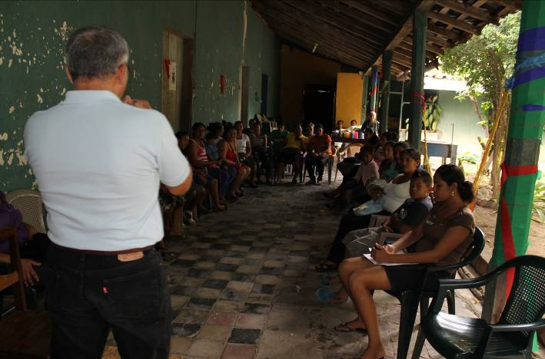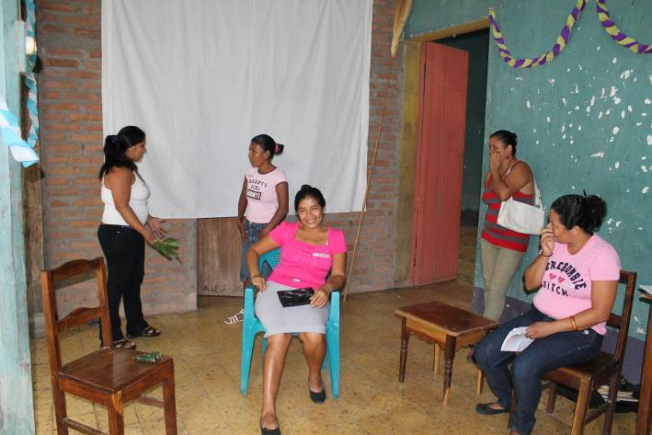
Women at the workshop with Miguel in Limay Women act out a socio-drama demanding their rights
In a number of cases young women with small children decided to proceed with legal action to get men to acknowledge they are the father of the child. Once that step is complete then the women will be able to take the next step of demanding the man for a food pension for the children. A food pension is like child support - but since people are poor here, the amount most men can give might just help cover the food. In one case a woman has two kids by two different men who don't pay the food pension. She lives in a village and washes and irons to make ends meet, and just barely. You can see the hardship of her life on her face. Her daughter has cerebral palsy. We will celebrate the day when she begins to get a food pension for her two children.
Remembering Philip Mitchell, by Nan McCurdy
My husband Phil and I spent three years in San Juan de Limay from 1985 to 1988. It is a town near the Honduran border and at that time was the war zone. We developed extremely close relationships with many people there and when I return it always feels like I am going home. Phil and I helped found a faith-based sistering relationship between people in Limay and people of faith in the Baltimore area in 1984 and this sister-ship is going strong today. Our United Methodist Church in Baltimore and many there were instrumental in all of this. There are committees of dedicated people still today, after more than twenty-five years, both in Baltimore and Limay; I am always thankful for them and all they do to maintain the human bridge between cultures - a bridge that has grown strong, as well as providing support to the people of Limay through small development projects.
In November, about three weeks before the 22nd anniversary of Phil's passing I got the very strong urge to go to Limay. Miguel and I were able to arrange to go to do trainings with two groups of women there who are advocates against violence, and who encourage and accompany other women when their rights are violated. When I called to look for one of the members of the Limay Sistering committee to let them know we were coming, I found them all together - these very dear old friends. The person I talked to, Olidia, said "Nan, do you know what we are meeting about?.... we are planning an anniversary celebration of Phil's life. We hope you can come".
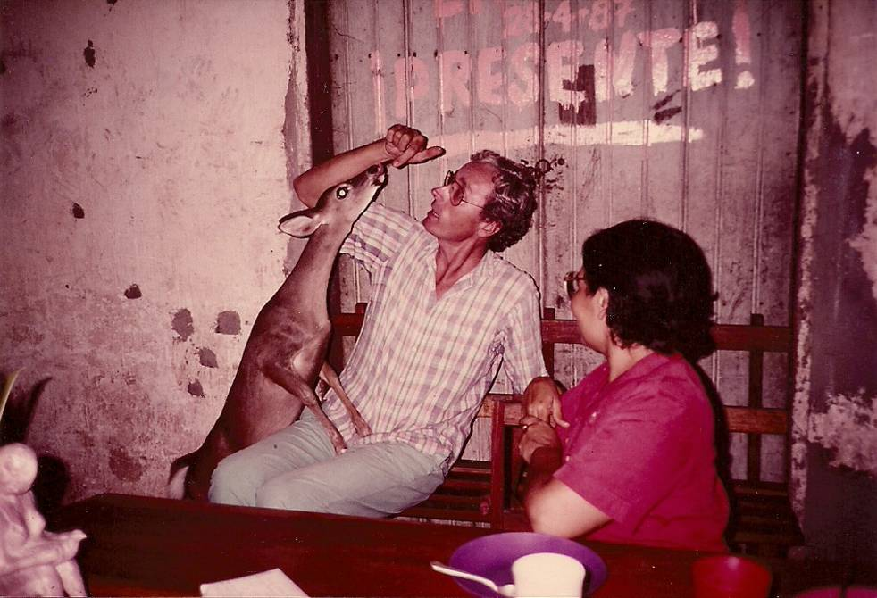
Phil and I had a pet deer during our three years in Limay. The woman is Nora Lavadie who today Coordinates the work with the women advocates. Our daughter, Nora, is named after her.
Phil's anniversary was an amazing time of remembrance and a celebration of all the life-giving experiences and projects that have come from this sistering relationship - and from the relationship-building. Many people told stories about Phil - I only wish my children could have been there.
Since then Miguel and I have been able to go three times to facilitate trainings and I have been able to spend quality time with dear friends of Phil and mine. This time with old friends to remember, tell stories and reconnect on a deep level has been very good for my soul. I have strongly felt God's presence in all of this.
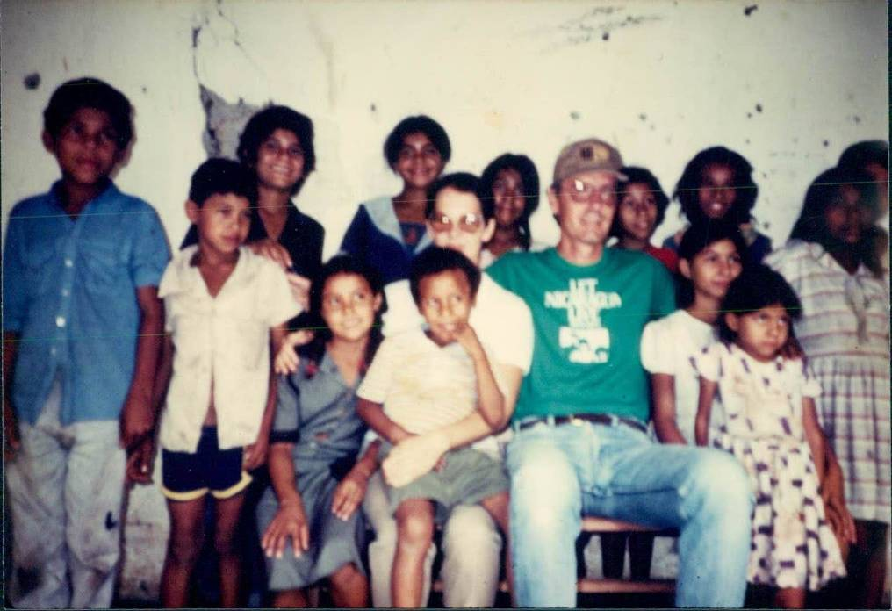
Nan and Phil with children in Limay. We know many of them now as adults.

